The preorder traversal sequence of a binary search tree is-
30 , 20 , 10 , 15 , 25 , 23 , 39 , 35 , 42
What one of the following is the postorder traversal sequence of the same tree?
- 10 , 20 , 15 , 23 , 25 , 35 , 42 , 39 , 30
- 15 , 10 , 25 , 23 , 20 , 42 , 35 , 39 , 30
- 15 , 20 , 10 , 23 , 25 , 42 , 35 , 39 , 30
- 15 , 10 , 23 , 25 , 20 , 35 , 42 , 39 , 30

Solution-

In this question,
- We are provided with the preorder traversal sequence.
- We write the inorder traversal sequence by arranging all the numbers in ascending order.

Then-
- Postorder Traversal : 30 , 20 , 10 , 15 , 25 , 23 , 39 , 35 , 42
- Inorder Traversal : 10 , 15 , 20 , 23 , 25 , 30 , 35 , 39 , 42

Now,
- We draw a binary search tree using these traversal results.
- The binary search tree so obtained is as shown-

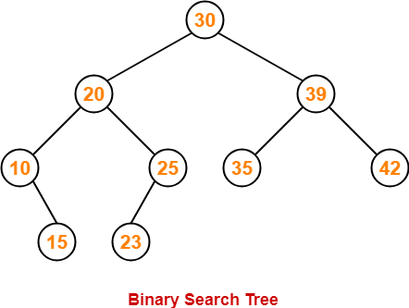

Now, we write the postorder traversal sequence-

Postorder Traversal :
15 , 10 , 23 , 25, 20, 35, 42, 39, 30

